### Acknowledgment

We would like to convey our sincerest gratitude to our Prime Supervisor and Technical Writing Professor **Dr. Nessreen ElAbiad**, for giving us the opportunity to do this report and for providing us with her invaluable guidance throughout. All of what she taught us about technical writing has greatly served us while doing this project.

Moreover, we would like to show our sincerest appreciation to our university, the **University of Cairo** for giving us the chance to study this course and for providing us with the place where we could all group together and discuss this report.

**Team Members’ Signatures:**

**Supervisor’s Signature:**

Abeer Hussein Mohamed Badr

Ahmed Ihab Yousry Abdelfatah

Essam Wisam Fouad Amin

Mohamed Ayman Mostafa Mohamed

We’am Bassem Hosni Ali

## Table of contents

1. **Introduction...............................................................................5**
2. Starting Note……………………………………………………….……......……..5
3. Astronomy Through History…………………………………………….....…..…6
4. **Stars at Birth: A cloudy Beginning..........................................7**
5. **Interstellar Clouds............................................................................7**
6. Stellar Nurseries………………………………………………………………..7
7. Gallery: Nebulae and Molecular Clouds……………………………………8
8. **Star Formation ..................................................................................9**
9. Gravitational Sequels………………………………………………………….9
10. The Nebular Disk Model…………………………………………………….10
11. Failed Stars……………………………………………………………………11
12. **Stars Alive: Elemental Essences............................................12**
13. **Main Sequences Stars...................................................................12**
14. Nuclear Fusion………………………………………………………………..12
15. The Formation of Elements…………………………………………………13
16. Gallery: Stars………………………………………………………………….15
17. **The finale........................................................................................16**
18. Stellar Expansion……………………………………………………………..16
19. Extreme Luminosity…………………………………………………………..17
20. Energy Exhausting…………………………………………………………...17
21. Supernovae and Hypernovae………………………………………………18

## Table of contents

1. **The Death of Stars: inevitable Doom...................................19**
2. **Fermionic Actions..........................................................................19**
3. The Uncertainty Priceable…………………………………………………..19
4. White Dwarfs………………………………………………………………….20
5. Neutron Stars…………………………………………………………………21
6. Gallery…………………………………………………………………………22
7. **Black Holes.....................................................................................23**
8. The Point of no Return………………………………………………………23
9. The Death of Black Holes……………………………...……………………25
10. **Conclusion...............................................................................27**
11. **Recommendations and Points of View................................28**
12. **References...............................................................................****31**

## preliminaries

### Executive Summary

This report represents the lifecycle of stars in chronological order, so we start by discussing their emergence from nebulae (interstellar clouds):

Nebulae are clouds of gases floating through interstellar space, once the appropriate conditions are met, regions in the nebula go through multiple stages of gravitational collapse, from clouds to cores to clumps to protostars, protostars resemble the first stage of stellar evolution, in this stage, they grow by accreting material from the surrounding cloud, once they are hot enough for fusion a main sequence star is born.

After discussing the birth of stars, it addresses their life and how they are responsible for all elements around us:

Stars are provided the pressure they need to balance the inward gravitational force and the energy they need to shine through fusion in their cores, however when the core becomes flooded with heavy elements the star may not be hot enough to undergo fusion any more thus it collapses until it is hot enough to undergo fusion once more, and at this point, the outer layers of the star expand for very large distances and we are left with a red supergiant.

And at last, we discuss their emergence into black holes, i.e. their death:

At some point the red giant/supergiant will not be able to sustain its own mass since its core becomes flooded with iron which doesn’t release energy upon fusion, thus it collapses, and as it does fermionic forces such as electron and neutron degeneracy pressure start acting in attempt to stop the collapse, if the core’s mass isn’t high enough the collapse may be stopped and the core settles as a white dwarf or neutron star respectively, however, if not a black hole is born.

## introduction

### Starting Note

In this report, our focus is to take you through a journey in time, traversing the life cycle of stars, from its lustrous beginning to its lightless end, one of the very special aspects concerning the life cycle of stars is how it comprises many different stages and that in each of these stages the star could be considered as a different object, there is much chance that you might be already recognizing many astronomical objects as if they are different even though all of them have been the same object at some point of their lives.

There lies a strong reason behind the name we chose for this report, it starts with stellar evolution, since stars evolve to many different objects during their lifecycle; they start out as clouds of hydrogen floating through interstellar space and then become stars that then evolve to red giants that might again form clouds that would lead to the birth of other stars that can die with supernova explosions and then can either become neutron stars or even better, black holes.

This very end of their life, which comprises in becoming a black hole, is the reason why the name ends with “lightless fates”, hence black holes are completely lightless, due to them not allowing any light to escape from their event horizons, they are perfect black bodies.

In this report, our journey will start by discussing the birth of such luminous spheres of wonder and once we are done with that, it will be time to discuss their life, which then when ends will drive us to their death and their emergence to black holes, having said this, it is important to note that in this report we will be frequently using equations and images to justify our statements and make the whole read much entertaining.

## introduction

### Astronomy Through History

“Early civilizations saw a night sky that was virtually the same as the one we see today, or at least the one we can see from a rural location, far away from all the smog and light pollution found in a large city.

Objects have shifted their positions slightly, but apart from that, our ancestors saw thousands of stars that seemed to be fixed on some celestial dome or sphere, slowly rotating around us.

They also saw other objects, most notably the sun and the moon, as well as five planets, all of which moved according to their own patterns, unrelated to the stars.

The planets were named for gods, and their Roman names are the ones we still use today, and for a long time, we believed that the earth was the center of the universe, with the mysterious heavens all around us.

While this notion seems utterly ancient to us now, it was the only conclusion we could have made in the absence of any scientific knowledge.” (*Professor Dave, YT)*

**[1]**

**[1]**

Fig. 1 Stars aligning with the Pyramids of Giza

The stars were considered so special, for example Egyptians aligned their pyramids and temples toward the north because they believed their pharaohs became stars in the northern sky after they died.

Author and theologian Dr. Joseph Seiss demonstrated in 1877 that the Great Pyramid of Giza is located at the exact intersection of the longest Iine of latitude and the longest line of longitude— **in other words, at the exact center of all the landmass on planet Earth.**

## interstellar clouds

### Stars at Birth: A Cloudy Beginning

|  |  |  |
| --- | --- | --- |
| From the previous section, it is clear how important stars were through history, so now it is time to question their origin, to do so we must be familiar with the term “nebulae”, which is exactly what we will learn about in this section. |  |  |

### Stellar Nurseries

In Latin, the word “nebula” means “cloud”, and in fact, that is just what they are, a nebula is considered to be a giant cloud of gas, dust and plasma, these clouds are usually found in the space between stars, also known as “interstellar space”.

Such clouds are classified according to their origin, and their interaction with light into the following:

1. **Planetary Nebulae:**

This type of nebula usually forms around stars that are near the end of their lives, where the former star keeps shedding its outer layers which then glow due to the radiation outcoming from the star.

1. **Supernova Remnant Nebulae:**

This type of nebulae is usually formed whenever a massive star dies, the outer layers of the dying star are violently cast into space through a Supernova explosion.

There are three other types which are based on the nebula’s interaction with light, these are absorption, reflection and emission nebulae, absorption and reflection nebulae are usually full of dust and they absorb, reflect light respectively, emission nebulae are usually full of high-temperature gas which in turn emits light due to the excitation of its atoms.

From this we can conclude that nebulae are related to the death of stars, so what do they have to do with their birth? Within nebulae there exists certain regions that can make it suitable for stars to form, that is why they are also often called stellar nurseries, stars are born within them!

## interstellar clouds

### Gallery

|  |  |  |
| --- | --- | --- |
| this section is a gallery involving various types of nebulae, the numbers shown in parenthesis indicate how many hours of exposure time were needed to take the picture. |  |  |

**[2]**

|  |  |  |
| --- | --- | --- |
| **The Helix Nebula** (18):  This is the closest nebula to earth, it is a planetary nebula, also note that planetary nebulae are only called that because they looked just like planets when old telescopes were being used. |  |  |

|  |  |  |
| --- | --- | --- |
| **IRAS 00044+6521**:  This reflection nebula is home to the infant star HBC 1 (the one lying at the center), the star is still immature but as time goes by it accretes more and more material from the surrounding nebula until hot enough for thermonuclear fusion. |  |  |

**[3]**

## STAR FORMATION

|  |  |  |
| --- | --- | --- |
| Now that we understand more about interstellar clouds, its time to dive in the process of star formation, however before we do so we must build up some basics concerning the role of gravity in such a process. |  |  |

### Gravitational Sequels

In the last section, we stopped after referring nebulae as “Stellar Nurseries” because they can make it suitable for stars to form once certain conditions are met, the main criterion responsible for this is known as “The Jeans’ collapse criterion” which was discovered by the British physicist James Jeans in the early 1900s.

 The criterion has the word “collapse” on it because the very first stage of stellar evolution is when some regions in the interstellar cloud undergo gravitational collapse, in other words these regions inwardly contract, gaining more heat energy and spinning more rapidly in the process.

 This criterion could be mathematically expressed as:

and as shown it is a function of temperature and density, given these parameters we can find out the minimum cloud radius that wouldn’t trigger a gravitational collapse, which is also known as the Jeans’ length, the criterion is derived from the fact that the gravitational potential energy of a self-gravitating system involving a spherical distribution of equal mass objects has to be twice that of its total kinetic energy to maintain hydrostatic equilibrium, this is also known as the virial theorem.

But the question is, what would make a cloud deviate from such an equilibrium state anyway in the first place, and what is currently thought is that external effects should be the cause for such a deviation, for example, a dying star may invoke a nearby cloud to trigger gravitational collapse, since shockwaves sent as it violently explodes may alter any of the arguments found in the jeans criterion.

## STAR FORMATION

|  |  |  |
| --- | --- | --- |
| In the last section, we understood the role of gravity in star formation, the very first step of star formation is when regions in the cloud gravitationally collapse, but then what is next? |  |  |

### The Nebular Disk Model

As the cloud collapses into smaller and denser regions, two very important factors come into play, the first is the conservation of angular momentum; since angular momentum is conserved the cloud spins more rapidly as it radius goes down, just like how the spin of a figure skater accelerates as she brings her arms in, and the second factor comes from the virial theorem which we talked about earlier, here as the radius goes down gravitational potential energy gets converted into heat until the cloud again reaches hydrostatic equilibrium.

At this point, what we have got is a core that mostly consists of dense gaseous material spinning at high temperature and pressure, this spin would also cause an accretion disk to form around the core, where flattened out matter spiral inwardly towards the core, feeding it with mass, and it is at this point that we call our core a protostar, so a star is born.

The core of the protostar gets even hotter and denser as time goes by, it starts off with a temperature around just a few thousand Kelvins and over millions of year heats up to reach as high as ten-million, once it is at this temperature it is thought to be hot enough to undergo thermonuclear fusion, and we might as well call it a main sequence star, meanwhile, as all of this is happening, material in the accretion disk start to collide together forming a planetary system that would then be orbiting the star, so stars usually form along with planetary systems.

The previous model is known as the nebular disk model, and it is the most widely accepted model explaining the formation and evolution of stars like our sun, to summarize the process what happens is that upon external effects(like the ones we talked about in the previous section) the cloud collapses into cores these then further collapse into clumps which then by time start growing into protostars that accrete surrounding material, once hot enough, a main sequence is born.

## STAR FORMATION

|  |  |  |
| --- | --- | --- |
| In the last section we got to the point where the infant star grows by accreting material from the cloud until its hot enough to undergo hydrogen fusion, this can take up to ten million years for some stars and may not happen at all for others, which is our discussion for this section. |  |  |

### Failed Stars

In various scenarios, protostars are not condemned to reach temperatures hot enough for hydrogen fusion, and in this case, we recognize them as failed stars, or more scientifically as brown dwarfs.

Although not necessarily brown, brown dwarfs span very low temperatures and are not considered an efficient energy source, most of what they radiate is infrared radiation and so little light, so they are not as easily observed when viewed from earth as compared to their successful counterparts, although they are not observed very so often, it is thought that in our galaxy there exists 100 billion of them, which means a brown dwarf for each hydrogen-burning star.

An important thing to note is that brown dwarfs shouldn’t be confused with gas giants, brown dwarfs are usually many times as massive and their process of formation is different than that of gas giants, even though brown dwarfs are considered to be failed stars, that does not stop them from having a planetary system that revolves around them.

An example of an interesting brown dwarf, is known as WISE 0855-0714, it has a surface temperature of around 243K which is 30 degrees colder than what it takes for ice to form, it emits no visible light and is about 7.2 light-years away from earth.

Now at this point, we are familiar with the first stage of stellar evolution, in the next few sections, we will be dealing with how stars strive for their life and how gravity is not always happy with the deal, till then remember that these luminous spheres of wonder are a reason for why life is taking place on earth, and perhaps manyother planets.

## Main sequence stars

### Stars Alive: Elemental Essences

|  |  |  |
| --- | --- | --- |
| In this chapter we will be addressing main sequence stars, those who successfully made it through the infant phase, the main source of energy for such stars is nuclear fusion, which is going to be our discussion for this section |  |  |

### Nuclear Fusion

Nuclear Fusion a type of nuclear reaction where two nuclei combine to form the nucleus of a different (usually heavier) element, this process generates tremendous amounts of energy, if we were to compare it to coal then one gram of nuclear fuel can release as much energy as twelve-thousand kilograms of coal!

Nevertheless being that powerful as an energy source does not come in the cost of nothing; nuclear fusion requires very extreme conditions to get going, that is why it generally occurs in the cores of stars, where the temperature is usually around hundreds of millions of degrees, and the pressure is around hundreds of billions of bars.

These conditions allow individual atoms, such as hydrogen in the core to be accelerated to very high speeds that force it to get close enough to other similar atoms such that the attractive nuclear force between them is larger than the repulsive coulombs force, the attractive nuclear force makes both atoms “fall” into each other forming the new element and releasing a huge net of energy.

Nuclear fusion is not to be confused with nuclear fission, in contrast to fusion nuclear fission is the splitting of a heavy, unstable nucleus into two lighter ones, so it is the other way around, and it does not generally happen within stars.

It is also important to note that both processes don’t always release energy, in some cases suchlike if the reaction is endothermic the reaction absorbs energy instead of releasing, nevertheless the equation that governs such processes is the famous Einstein relation:

## Main sequence stars

Where here is the difference between the initial and final masses of the nuclear reaction. If this quantity is positive then the missing mass must have been converted to energy, so energy is released, however, if it is negative then the reaction requires energy to fire off which might be the case for some nuclear fusion reactions as we previously mentioned.

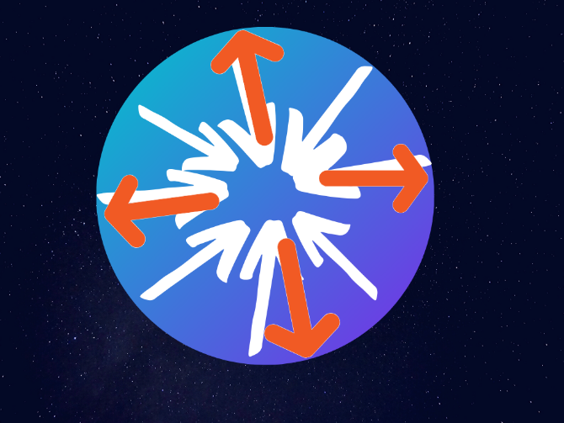Now that we understand more about the concept of nuclear fusion, we need to think about how the star uses the energy obtained from it:

Consider this blue ball as our former star, to maintain hydrostatic equilibrium i.e. for the star to not collapse upon itself it must overcome the inward gravitational forces that act on its structure (shown as white arrows) and to do so it exhibits a radially outward force in the form of radiation pressure (shown as orange arrows), which is primarily sourced from fusion.

Fig. 4 Gravity (White) VS Radiation (Orange)

Undoubtedly energy obtained from fusion is also used to make the star shine, the fusion reactions release electromagnetic waves in the form of gamma rays in the core and then other forms of radiation (such as visible light and heat) at the surface.

### The Formation of Elements

One of the most important things about nuclear fusion, is how it is responsible for the formation of all the elements around us, hence the famous quote “We are all stardust”.

The early universe only involved only the low-mass elements, hydrogen and helium, as they were produced in the hot and dense conditions of the birth of the universe itself.

## Main sequence stars

The birth, life, and death of a star is described in terms of nuclear reactions such as fusion, the heavier chemical elements that make up the matter we observe throughout the universe were created in these reactions.

It is also worthy to note that Approximately 73% of the mass of the visible universe is in the form of hydrogen. Helium makes up about 25% of the mass, and everything else represents only 2%. While the abundance of these more “heavier” elements seems quite low, it is important to remember that most of the atoms in our bodies and Earth are a part of this small portion of the matter of the universe.

The following schematic shows how helium can be obtained from the nuclear fusion of hydrogen:

**[4]**

Fig. 5 Thermonuclear Fusion

As shown the process goes through multiple stages, with energy being released in each stage, first is the reaction between two protons to form deuterium, a hydrogen isotope, the deuterium nuclei then interacts with a proton to form helium isotopes which further interact to form unstable beryllium that then breaks apart giving helium and two protons.

## Main sequence stars

### Gallery

|  |  |  |
| --- | --- | --- |
| this section is a gallery involving two interesting stars, first the star that is statistically shown to be older than the current age of the universe and the next is the largest star known to exist. |  |  |

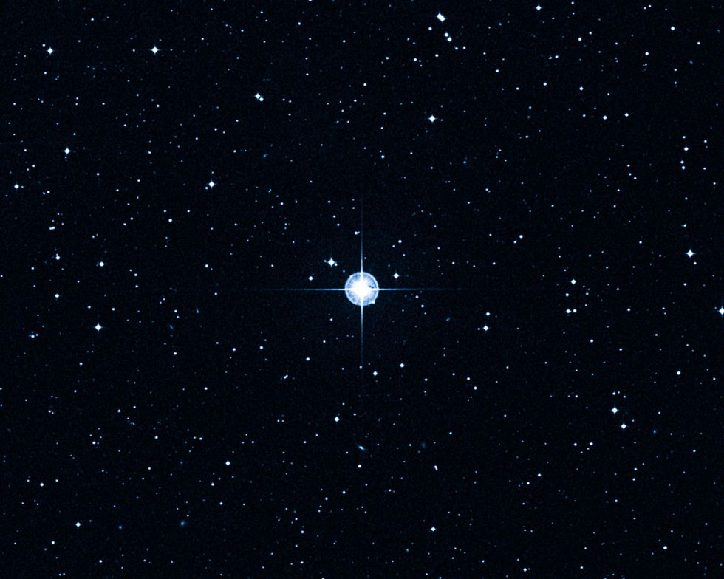

**[5]**

|  |  |  |
| --- | --- | --- |
| **The Methuselah**: Despite how beautiful the star is, it is the oldest one known. A study established in 2013 that used the fine guidance sensors of the Hubble Telescope of NASA estimate its age to be about 0.66 billion years, which is even older than the known age of the universe. |  |  |

|  |  |  |
| --- | --- | --- |
| **UY Scuti**: This star is the largest one in our galaxy, even though it is no more than ten times the mass of our sun, it is 430368875 times as large in volume, the star is currently in the red supergiant phase. |  |  |

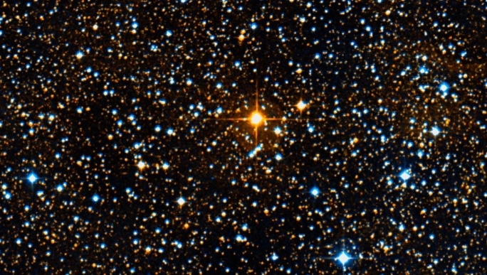

**[6]**

## The finale

|  |  |  |
| --- | --- | --- |
| Now that we understand the process of fusion, we have to consider various scenarios where fusion stops for some reason, which is our discussion for this section. |  |  |

### Stellar Expansion

As we previously demonstrated, thermonuclear fusion of hydrogen into helium is constantly taking place in the core of main sequence stars such as to provide them with enough energy to counterbalance gravity and shine, however this supply of hydrogen in the core does not last forever, at some point, usually after about a few billion years for stars as massive as our sun hydrogen starts to run out, and once that happens the core undergoes gravitational collapse, a process in which it contracts inwardly due to not being able to resist gravity through its outward radiation pressure, so the core contracts until hot enough to fuse helium into heavier elements such as carbon, once it reaches this state its outer layers also start to greatly expand, these layers are mostly light hydrogen which can now be easily pushed through the radiation pressure outcoming from the now helium-burning core.

**[7]**

Fig. 8The clearest-ever image of a red giant

Once a star with mass comparable to our sun reaches this stage, we call it a red giant, the presented image shows a red giant known as Betelgeuse, it is younger than our sun but it is just living much more quickly.

## The finale

### A picture containing food, light Description automatically generatedThis image represents the sun as a red giant, this is likely to happen in about 4-5 billion years, notice that it has greatly increased in size, at this point we expect it to have a surface temperature of just 5000 degrees, the inner core of our planet is even hotter than that.

**[8]**

Fig .9 The sun engulfing earth as a red giant

### Extreme Luminosity

When compared to the former star, the red giant is not just much greater in size but also thousands of times more luminous, the reason for this is that energy now is being emitted by a much larger radiating surface, this is also the reason for why they have quite low surface temperatures; since the same energy is being dissipated over larger surface areas.

### Energy Exhaustion

The scenario we presented in the start of the previous section could be extended when dealing with stars of masses much larger than that of our sun, but in this case, once helium runs out of the core the cycle repeats, so we get a helium shell and a carbon-burning core and so on and in this case we call it a red supergiant, however, no matter what this process stops at iron, meaning that regardless of how massive the star is, it will not be able to fuse iron into any heavier elements, so it becomes exhausted of energy and is rendered unable to counterbalance gravity, so gravity takes over and the star starts to collapses.

## The finale

|  |  |  |
| --- | --- | --- |
| In the last section, we stopped at the point in which the red supergiant collapses upon itself since unable to counterbalance gravity, one consequence of this is a powerful luminous stellar explosion, which is our discussion for this section. |  |  |

### Supernovae and Hypernovae

As the star inwardly collapses, material is forcefully drawn into its core, yet in the meantime the core’s structure atomically changes such as to be able to fight back gravity, once it succeeds in this the core stops collapsing, and all the material further away that is still falling into the core get hit by its incredibly hard-now stable surface, so they energetically bounce back causing a massive explosion that indicates the death of the star, the left behind core is no longer a star but rather a new cosmological object that we will learn about in the next chapter, besides this object the material left from the supernova is now spread all over the region around the core, forming a supernova remnant nebula which might give birth to another star in the future.

**[9]**

Fig. 10 Remaining elements from a supernova form a nebula.

The shown image represents a supernova remnant nebula known as Simeis 147, it is star has gone supernova since forty-thousand years, and the nebula has expanded to become 140 light-years over this period.

## FERMIONIC ACTIONS

In some cases, if the supernova is so energetic, which is usually the case if the former star is more than thirty times as massive as our sun, we instead call it a hypernova. The following image from NASA shows a star before it exploded (on the right) and then the star after it exploded (on the left) notice how luminous is the explosion.

**[10]**

Fig. 11 A star that has gone supernova(exploded)

|  |  |  |
| --- | --- | --- |
| In the last section we mentioned that the core’s structure atomically changes as it collapses but we have not gone into any details further than that, in this chapter we will use equations to understand this process, and classify different fates that upon these equations could be decided for the star. |  |  |

### The Death of Stars: Inevitable Doom

### The uncertainty principle

Let us consider stars with mass comparable to our sun, such stars are not likely to produce supernova explosions as they die, as red giants, once they run out of fuel, they collapse inwardly due to being unable to counterbalance gravity. This collapse goes on until halted by electrons, to explain how this process works we need to learn about the Heisenberg uncertainty principle, which could be mathematically expressed as:

## FERMIONIC ACTIONS

Where correspond to the deallocation in distance and momentum respectively and is Planck's constant. As the star collapses the probability of finding electrons in a smaller region of space increases, thus the deallocation decreases leading to an increase in .

At some point when is low enough electrons may travel with very high speeds that may even approach that of light originating what is known as electron degeneracy pressure which works such as to push against gravity, so the collapse stops. Once it stops the core stabilizes as a cosmological object known as a white dwarf, and while all of this is happening the outer layers of the star get continuously shed forming a planetary nebula.

**[11]**

Fig. 12 The planetary nebula Abell 39

### White Dwarfs

The stellar core, which is now known as a white dwarf is composed mostly of electron-degenerate matter which is so dense that one teaspoon of such matter can weight up to fifteen tons.

Keep in mind that at this point no fusion occurs inside the white dwarf and that its faint luminosity only comes from the emission of energy that is stored within it, in other words, it has no energy source, and this means that with enough time all of the energy will be radiated away forming what’s known as a black dwarf

## FERMIONIC ACTIONS

when all of the energy is exhausted, but still radiation is way too slow that it is estimated that it would take for a white dwarf more time than the current age of the universe to become a black dwarf, which makes them more of theoretical objects than actual observed ones.

|  |  |  |
| --- | --- | --- |
| In this section we dealt with stars of mass comparable to our sun, for stars that are many times as massive, electron degeneracy pressure fails to oppose the inward gravitational collapse, since electrons would have to move at speeds higher than that of light to stop it, thus it is stopped by another mechanism which we will talk about in the following section. |  |  |

### Neutron Stars

As electron degeneracy pressure fails to overcome gravity, the star collapses upon itself even more, until halted by what is known as neutron degeneracy pressure, here what happens is that electrons and protons that form the atoms of the core combine together to form neutrons, and by doing so the core is able to overcome gravity and then stabilize as what is known as a neutron star, meanwhile the outer layers are cast violently into space through a supernova explosion.

The former core is now made of degenerate matter that is extremely dense, one teaspoon of this can weight more than one billion tons! furthermore, some neutron stars can exhibit extraordinary magnetic and spin properties, these are classified into magnetars and pulsars, the fastest known pulsar is known as PSR J1748−2446ad and it spins 716 times per second, as for magnetars they exhibit extreme magnetic fields that can reach as high as teslas, which is high enough to make cars fly towards one of them free of fuel once placed close enough to earth, luckily the closed one is nine-thousand light-years away.

## FERMIONIC ACTIONS

### Gallery

|  |  |  |
| --- | --- | --- |
| this section is a gallery involving two interesting neutron stars, both images have been taken using telescopes that take advantage of the electromagnetic radiation outcoming from the stars. |  |  |

|  |  |  |
| --- | --- | --- |
| **The Vela Pulsar**:  This pulsar is the brightest one ever in radio frequencies, it spins at only about twelve times per second and as it does it shoots matter from its poles forming a pulsar wind nebula. |  |  |

|  |  |  |
| --- | --- | --- |
| **SGR 1900+14**: This image represents a magnetar, magnetars are usually dim but this image shows it as glowing since it was taking using x-ray telescopes, surrounding the magnetar is a nebula that is two light years across. |  |  |

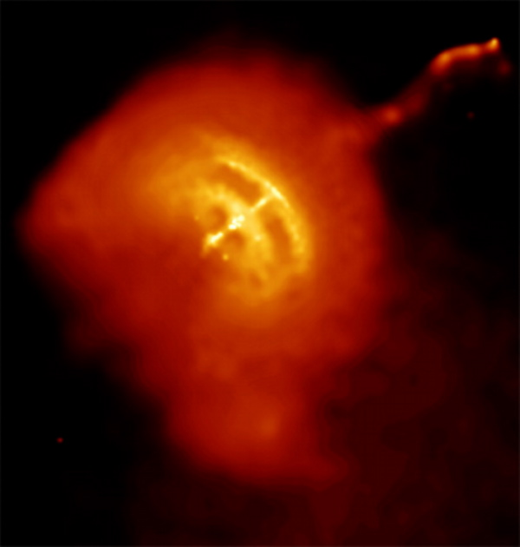

**[12]**

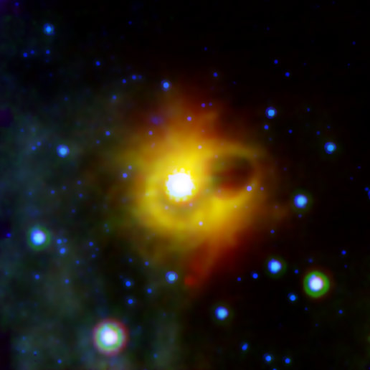

**[13]**

## BLACK HOLES

|  |  |  |
| --- | --- | --- |
| At this point we have dealt with stars in which fermionic actions, namely electron and neutron degeneracy pressure are able to stop the collapse, however, if the star is massive enough even neutron degeneracy pressure will fail to stop it from collapsing, so what is next? That is our discussion for this section. |  |  |

### The Point of no Return

Let us start by addressing the masses in which electron and neutron degeneracy pressure fail to overcome gravity:

* Electron degeneracy pressure fails at 1.44M☉ (Solar Masses), this is known as Chandrasekhar’s limit, this is the upper mass limit for a white dwarf.
* Neutron degeneracy pressure fails at 2.16M☉, this is known as the Tolman–Oppenheimer–Volkoff limit, this is the upper mass limit for a neutron star.

Meanwhile, if the mass of the supergiant’s core exceeds 2.16M☉ the whole mass is thought to be compressed into a very tiny region, which is known as the singularity, in the region surrounding this singularity, gravity is so intense that even light cannot escape from it once close enough, the name we give to such region is “Black Hole”.

Now to mathematically show why light cannot escape from this region, we can use the equation for escape velocity and set V as the speed of light:

The escape velocity is given by:

Where G is the Universal Gravitational Constant and M is the mass of the gravitational source and R is its radius

## BLACK HOLES

Now by setting V as the speed of light and solving for R, we get:

Which shows that any object with mass and radius satisfying this relation will be able to prevent light from escaping from its surface, now if we apply the formula to our sun which is of mass we get that it must have a radius of in order to satisfy this, in other words, it must be compressed to less than one Femto ) of its size, which is very unlikely for stars like our sun since electron degeneracy pressure will be able to stop the collapse far before this point, however for high-mass collapsing cores reaching such critical radius may be no issue, especially when both electron and neutron degeneracy pressure fail to stop the collapse early on.

So once a core reaches this point, it becomes a **black hole**, and the mathematical border that defines the black hole is known as the event horizon.

Due to their interaction with light, black holes underlie very special properties when compared to other cosmological objects, for example, another consequence of their intense gravitational field is time dilation, let us start with the displacement equation:

Now by applying the previous formula for light:

## BLACK HOLES

From this, as light bends due to the intense gravitational field from the black hole increases.

But since the speed of light must remain constant, what happens is that the change in time increases, in other words, passes more slowly.

### The Death of Black Holes

“Black holes are among the most destructive objects in the universe, anything that gets too close to the central singularity of a black hole, be it an asteroid, planet, or star, risks being torn apart by its extreme gravitational field.

And if the approaching object happens to cross the event horizon of the black hole, then it will disappear and never re-emerge, adding to the black hole’s mass and expanding its radius in the process.

There is nothing we could throw at a black hole that would do the least bit of damage to it, even another black hole will not destroy it, the two will simply merge into a larger black hole, releasing a lot of energy as gravitational waves in the process.

By some accounts, it is possible that the universe may eventually consist entirely of black holes in a very distant future. Yet, there may be a way to destroy, or “evaporate” these objects after all.

In 1974, Stephen Hawking theorized a process that could lead a black hole to gradually lose mass, it is based on a well-established phenomenon called quantum fluctuations of the vacuum.

## BLACK HOLES

According to quantum mechanics, a given point in spacetime fluctuates between multiple possible energy states. These fluctuations are driven by the continuous creation and destruction of virtual particle pairs, which consist of a particle and its oppositely charged antiparticle. Normally, the two collide and annihilate each other shortly after appearing, preserving the total energy.

But what happens when they appear just at the edge of a black hole’s event horizon? If they are positioned just right, one of the particles could escape the black hole’s pull while its counterpart falls in. It would then annihilate another oppositely charged particle within the event horizon of the black hole, reducing the black hole’s mass, and increasing its temperature.

**[14]**

Fig. 15 The mass and temperature of a black hole are inversely correlated.

Meanwhile, to an outside observer, it would look like the black hole had emitted the escaped particle. Thus, unless a black hole continues to absorb additional matter and energy, it’ll evaporate particle by particle, at an excruciatingly slow rate.” *(Fabio Pacucci, Ted-ed)*

How slow?

About times of the current age of the universe, for a black hole with mass equal to that of our sun.

## EXTRAS & CONCLUSION

### Conclusion

Early civilizations saw a night sky that was virtually the same as the one we see today, or at least the one we can see from a rural location, far away from all the smog and light pollution found in a large city.

In conclusion, although this night sky looked so simple, a lot of secrets are hidden within it, as we showed in our report, a star is not just one object, it continuously evolves through its life into many different ones in order to keep hold of itself against gravity, this may last until it emerges into a black hole, an object of which even modern science cannot completely understand.

## rECOMMENDATIONS & POINTS OF VIEW

### Points of View

One day, when I looked at the night sky, I found a lot of stars, I stared at them and kept asking myself a lot of questions, like how are they born? Do they live forever or die? What are black holes? Until one day I decided to read articles about their lifecycle, and I found it to be very interesting, I discovered a lot of things that I had no idea about it. So, I decided to study up this topic very well with my friends and we wrote this report about them. I highly recommend this topic to everyone because most people don’t know about the stars’ life cycle and most of them either think that there is no existence for black holes or have a completely wrong idea about it, I also think that in the future this topic will be very important to an extent that there will be a specific course about it in schools.

-Ahmed Ihab Yousry Abd-ElFattah

The study of astronomy shows how beautiful and organized is our universe, but it isn’t limited to that since it opens pathways for the advancement of other sciences that could change the life of humanity forever, a concrete example for this is thermonuclear fusion which occurs at the cores of stars, this process is so efficient at obtaining energy that **one gram** of nuclear fuel can provide as much energy as **12,000 kilograms** of coal, moreover, it does not emit any harmful greenhouse gases, its byproducts are in the form of inert gases such as helium that are harmless to our planet. By just learning more about stars, perhaps in the future the whole world can on this type of clean energy, another example is how physics is correlated to our current knowledge about astronomy, we know more of both by learning from just one of them, the main point about astronomy is that it seeks to answers the big questions about our universe.

-Essam Wisam Fouad Amin

## rECOMMENDATIONS & POINTS OF VIEW

Astronomy is one of the most ancient sciences of history. Most ancient cultures, such as Ancient Egypt, used this science to describe unusual events and depart from deserts. Also, nowadays, most nations are seeking to use renewable energy sources such as solar energy. So, I found it is interesting to learn and read more and more about stars that are the first-ever created objects in the universe believing that knowing more about them might help us make most of their energy that is generated by nuclear fusion and prevent potential energy shortages while keeping the environment safe as well. I found a lot of fascinating knowledge after reading a little about them. I found out how they would break our absolute space-time thinking principles.

-We’am Bassem Hosni Ali

What do the stars tell us? That is what I was thinking about every time I see the sky. Just a simple example of the power and magic of the sky that made me more interested in the stars and encouraged me to make this report with my mates: we can keep precise track of the seasons by observing the apparent motion of the Sun and the rising times of bright stars. In early agrarian societies, such knowledge was critical for survival. Sunrise and sunset positions on the horizon mark the seasons. The first time a bright star (such as Sirius) can be seen rising ahead of the Sun is another seasonal marker. How this knowledge affected our lives was the catalyst for me to try to know more about the stars and after I did I could not be more impressed.

-Abeer Hussein Mohamed Badr

## rECOMMENDATIONS & POINTS OF VIEW

Since the beginning of life, humans asked themselves what is the universe?? What’s behind it? What are the big shiny masses which stick into the sky? How have they been formed and when? All these mysterious questions make our scientist have to think about it and find a reasonable answer which can satisfy all of us. And over years and years, many theories have been done. Yet, they only reached to a percent of the answer to our questions. In this research we have presented such answers in a simple and abbreviated way so, any person can understand it. every day our knowledge and information about the universe increase gradually and may be in one day every child in the world will know the universe facts.

-Mohamed Ayman Mostafa Mohamed

## References in chronological order

[1] fire607, J. (2020). *Stars aligning with the pyramids* [Image]. Retrieved 4 March 2020, from https://www.reddit.com/r/Egypt/comments/eknbcf/stars_aligning_with_the_pyramids/?utm_source=share&utm_medium=web2x.

[2] *Intergalactic Glory Hole*. (2019). [Image]. Retrieved 20 February 2020, from https://www.reddit.com/r/dontputyourdickinthat/comments/dkeml8/intergalactic_glory_hole/?utm_source=share&utm_medium=web2x.

[3] Schmidt, J. (2016). *A diamond in the dust* [Image]. Retrieved 16 February 2020, from https://www.spacetelescope.org/images/potw1607a/.

[4] Shapley, P. (2011). *What is Fusion?* [Image]. Retrieved 4 March 2020, from http://butane.chem.uiuc.edu/pshapley/GenChem1/L1/3.html.

[5] Wall, M. (2013). *Strange 'Methuselah' Star Looks Older Than the Universe* [Image]. Retrieved 8 March 2020, from https://www.space.com/20112-oldest-known-star-universe.html.

[6] Brown, D. (2015). *UY Scuti, Rutherford Observatory* [Image]. Retrieved 14 March 2020, from https://phys.org/news/2015-12-biggest-star-universe.html.

[7] *Space Photos of the Week*. (2020). [Image]. Retrieved 20 March 2020, from https://www.wired.com/story/space-photos-of-the-week-betelgeuse/.

[8] *What Happens When The Sun Becomes A Red Giant?*. (2014). [Image]. Retrieved 19 March 2020, from https://futurism.com/the-day-with-no-tomorrow.

## References

[9] Plague, B. (2019). *Spaghetti nebula* [Image]. Retrieved 22 March 2020, from https://www.reddit.com/r/Astronomy/comments/9rh5kl/spaghetti_nebula/.

[10] *Supernova 1987A illuminates after 30 years*. (2017). [Image]. Retrieved 25 May 2020, from https://www.aao.gov.au/news-media/media-releases/Supernova1987A-30.

[11] Mt. Lemmon SkyCenter. (2012). *Spherical Planetary Nebula Abell 39* [Image]. Retrieved 25 March 2020, from https://apod.nasa.gov/apod/ap121008.html.

[12] Nowakowsk, T. (2016). *The 'glitching' of the Vela pulsar* [Image]. Retrieved 26 March 2020, from https://phys.org/news/2016-02-glitching-vela-pulsar.html.

[13] NASA/JPL-Caltech. (2012). *Magnetar SGR 1900+14* [Image]. Retrieved 25 March 2020, from https://en.wikipedia.org/wiki/Magnetar#/media/File:Magnetar_SGR_1900+14.jpg.

[14] Cai, Y. (2010). *Approximate Hawking temperature as a function of black hole mass* [Image]. Retrieved 17 May 2020, from https://www.researchgate.net/figure/Approximate-Hawking-temperature-as-a-function-of-black-hole-mass-see-Eq-44-The_fig1_45928135.